

**Programming Fundamentals**

# Assignment: 01

**Submitted by:** Muhammad Raffey

**Submitted to:** Sir Ahmad Faraz

**Section:** BSCS 2I

**Sap ID:** 70153209

# Q1- Total Units and Bill Calculator

## **Code:**

**#include <iostream>**

**using namespace std;**

**int main()**

**{**

**int prevRead, currRead;**

**cout << "Enter Previous Reading: ";**

**cin >> prevRead;**

**cout << "Enter Current Reading: ";**

**cin >> currRead;**

**int totalUnits = currRead - prevRead;**

**cout << "Total Units: " << totalUnits << endl;**

**if (totalUnits > 1 && totalUnits <= 100)**

**{**

**float unitPrice, totalAmount;**

**unitPrice = 4.86;**

**totalAmount = unitPrice * totalUnits;**

**cout << "Unit Price According to Units Consumed: " << unitPrice << "\nTotal Amount: " << totalAmount;**

**}**

**else if (totalUnits > 100 && totalUnits <= 200)**

**{**

**float unitPrice, totalAmount;**

**unitPrice = 6.57;**

**totalAmount = unitPrice * totalUnits;**

**cout << "Unit Price According to Units Consumed: " << unitPrice << "\nTotal Amount: " << totalAmount;**

**}**

**else if (totalUnits > 200 && totalUnits <= 350)**

**{**

**float unitPrice, totalAmount;**

**unitPrice = 9.21;**

**totalAmount = unitPrice * totalUnits;**

**cout << "Unit Price According to Units Consumed: " << unitPrice << "\nTotal Amount: " << totalAmount;**

**}**

**else if (totalUnits > 350 && totalUnits <= 800)**

**{**

**float unitPrice, totalAmount;**

**unitPrice = 14.81;**

**totalAmount = unitPrice * totalUnits;**

**cout << "Unit Price According to Units Consumed: " << unitPrice << "\nTotal Amount: " << totalAmount;**

**}**

**else if (totalUnits > 800 && totalUnits <= 999)**

**{**

**float unitPrice, totalAmount;**

**unitPrice = 19.25;**

**totalAmount = unitPrice * totalUnits;**

**cout << "Unit Price According to Units Consumed: " << unitPrice << "\nTotal Amount: " << totalAmount;**

**}**

**else if (totalUnits > 999 && totalUnits <= 2500)**

**{**

**float unitPrice, totalAmount;**

**unitPrice = 24.58;**

**totalAmount = unitPrice * totalUnits;**

**cout << "Unit Price According to Units Consumed: " << unitPrice << "\nTotal Amount: " << totalAmount;**

**}**

**else if (totalUnits > 2500)**

**{**

**float unitPrice, totalAmount;**

**unitPrice = 34.12;**

**totalAmount = unitPrice * totalUnits;**

**cout << "Unit Price According to Units Consumed: " << unitPrice << "\nTotal Amount: " << totalAmount;**

**}**

**else**

**{**

**cout << "Invalid Input";**

**}**

**}**

## **Output:**

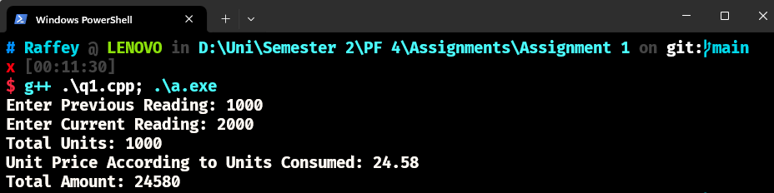

# Q2- ATM System

## **Code:**

**#include <iostream>**

**#include <string>**

**using namespace std;**

**int main()**

**{**

**int balance = 1000;**

**while (true)**

**{**

**string input = "";**

**cout << "Enter 1 to deposit\nEnter 2 to withdraw\nEnter 3 to check balance\nEnter 4 to exit\n";**

**cout << "\n------------------------------------------\n";**

**cin >> input;**

**cout << "------------------------------------------\n";**

**if (input == "1")**

**{**

**int amount = 0;**

**cout << "Enter amount to deposit\n";**

**cin >> amount;**

**cout << "You Deposited: " << amount << "$" << endl;**

**balance += amount;**

**cout << "Your New Balance is: " << balance << "$ " << endl;**

**cout << "\n------------------------------------------\n";**

**}**

**else if (input == "2")**

**{**

**int amount = 0;**

**cout << "Enter amount to withdraw\n";**

**cin >> amount;**

**if (amount > balance)**

**{**

**cout << "Insufficient balance " << balance << "$" << endl;**

**cout << "\n------------------------------------------\n";**

**continue;**

**}**

**else**

**{**

**cout << "You Withdrew: " << amount << "$" << endl;**

**balance -= amount;**

**cout << "Your New Balance is: " << balance << "$ " << endl;**

**cout << "\n------------------------------------------\n";**

**}**

**}**

**else if (input == "3")**

**{**

**cout << "Your Current Balance is: " << balance << "$ " << endl;**

**cout << "\n------------------------------------------\n";**

**}**

**else if (input == "4")**

**{**

**cout << "Thank You For using Raffey's ATM" << endl;**

**break;**

**}**

**else**

**{**

**cout << "Invalid input\n";**

**}**

**}**

**}**

## **Output:**

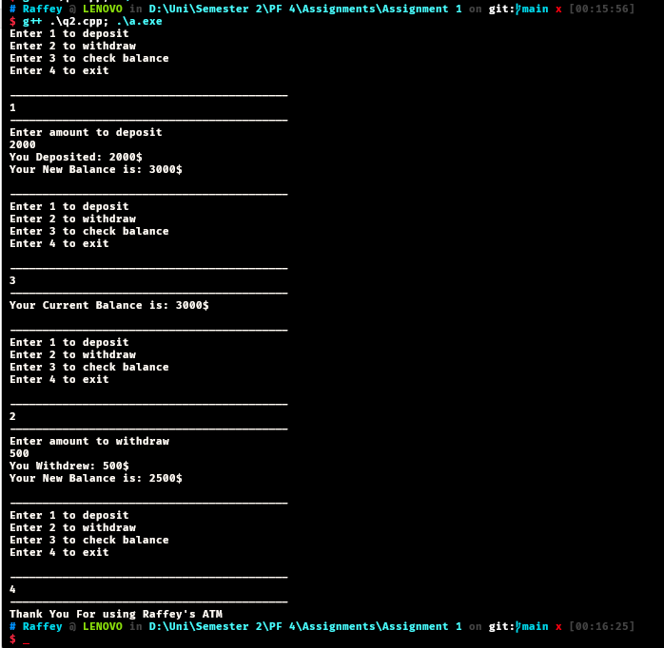

# Q3- Coffee Shop

## **Code:**

**#include <iostream>**

**#include <string>**

**using namespace std;**

**int main()**

**{**

**cout << "Welcome to Raffey's Coffee Shop" << endl;**

**while (true)**

**{**

**string input = "";**

**cout << "Enter 1 for Espresso\nEnter 2 to for Latte\nEnter 3 for Cappuccino\nEnter 4 to exit\n";**

**cout << "\n------------------------------------------\n";**

**cin >> input;**

**// cout << input;**

**cout << "------------------------------------------\n";**

**if (input == "1")**

**{**

**string size = "";**

**cout << "Enter 1 for small(2$)\nEnter 2 to for Medium(3$)\nEnter 3 for Large(4$)\n\t";**

**cin >> size;**

**cout << "\n------------------------------------------\n";**

**if (size == "1")**

**{**

**cout << "You ordered small espresso" << endl;**

**cout << "\n------------------------------------------\n";**

**}**

**else if (size == "2")**

**{**

**cout << "You ordered medium espresso" << endl;**

**cout << "\n------------------------------------------\n";**

**}**

**else if (size == "3")**

**{**

**cout << "You ordered large espresso" << endl;**

**cout << "\n------------------------------------------\n";**

**}**

**else**

**{**

**cout << "Invalid Size" << endl;**

**cout << "\n------------------------------------------\n";**

**}**

**}**

**else if (input == "2")**

**{**

**string size = "";**

**cout << "Enter 1 for small(3$)\nEnter 2 to for Medium(4$)\nEnter 3 for Large(5$)\n\t";**

**cin >> size;**

**cout << "\n------------------------------------------\n";**

**if (size == "1")**

**{**

**cout << "You ordered small Latte" << endl;**

**cout << "\n------------------------------------------\n";**

**}**

**else if (size == "2")**

**{**

**cout << "You ordered medium Latte" << endl;**

**cout << "\n------------------------------------------\n";**

**}**

**else if (size == "3")**

**{**

**cout << "You ordered large Latte" << endl;**

**cout << "\n------------------------------------------\n";**

**}**

**else**

**{**

**cout << "Invalid size" << endl;**

**cout << "\n------------------------------------------\n";**

**}**

**}**

**else if (input == "3")**

**{**

**string size = "";**

**cout << "Enter 1 for small(4$)\nEnter 2 to for Medium(5$)\nEnter 3 for Large(6$)\n\t";**

**cin >> size;**

**cout << "\n------------------------------------------\n";**

**if (size == "1")**

**{**

**cout << "You ordered small Cappuccino" << endl;**

**cout << "\n------------------------------------------\n";**

**}**

**else if (size == "2")**

**{**

**cout << "You ordered medium Cappuccino" << endl;**

**cout << "\n------------------------------------------\n";**

**}**

**else if (size == "3")**

**{**

**cout << "You ordered large Cappuccino" << endl;**

**cout << "\n------------------------------------------\n";**

**}**

**else**

**{**

**cout << "Invalid Size" << endl;**

**cout << "\n------------------------------------------\n";**

**}**

**}**

**else if (input == "4")**

**{**

**cout << "Thank you for using Raffey's Coffee Shop" << endl;**

**cout << "\n------------------------------------------\n";**

**break;**

**}**

**else**

**{**

**cout << "Invalid Type" << endl;**

**cout << "\n------------------------------------------\n";**

**}**

**}**

**}**

## **Output:**

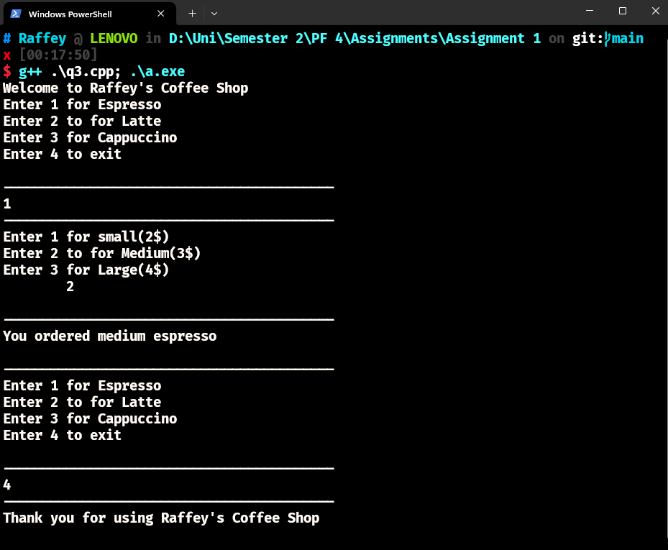

# Q4- Pattern

## **Code:**

**#include <iostream>**

**using namespace std;**

**int main()**

**{**

**int n = 5;**

**for (int i = 1; i <= n; i++)**

**{**

**for (int j = i; j < n; j++)**

**{**

**cout << " ";**

**}**

**for (int k = 1; k <= (2 * i - 1); k++)**

**{**

**cout << "*";**

**}**

**cout << endl;**

**}**

**for (int i = n - 1; i >= 1; i--)**

**{**

**for (int j = n; j > i; j--)**

**{**

**cout << " ";**

**}**

**for (int k = 1; k <= (2 * i - 1); k++)**

**{**

**cout << "*";**

**}**

**cout << endl;**

**}**

**return 0;**

**}**

## **Output:**